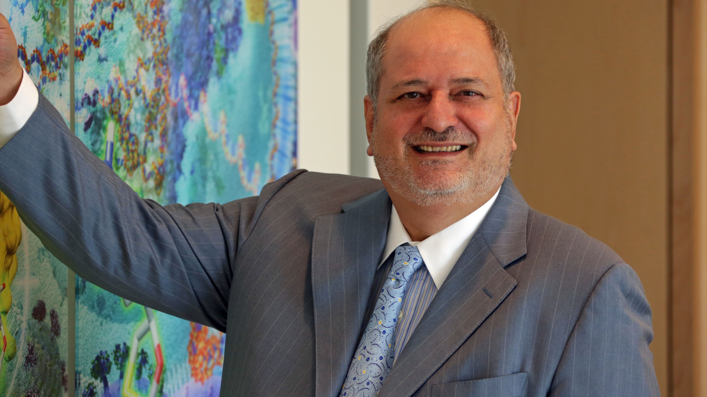
Dr. Raymond F. Schinazi is the Frances Winship Walters Professor of Pediatrics and Director of the Laboratory of Biochemical Pharmacology at Emory University. He serves as Senior Research Career Scientist at the Atlanta Department of Veterans Affairs and Director of the Scientific Working Group on Viral Eradication for the NIH-sponsored Emory University Center for AIDS Research (CFAR). Dr. Schinazi received his BSc (1972) and PhD (1976) in chemistry from the University of Bath, England. He has authored over 500 peer-reviewed papers and 7 books and holds 92 issued U.S. patents and over 120 non-U.S. national stage patents and patent applications, which have resulted in 12 New Drug Applications (NDA). A world leader in nucleoside chemistry, Dr. Schinazi is best known for his pioneering work on HIV and HCV drugs d4T (stavudine), 3TC (lamivudine), FTC (emtricitabine/Emtriva), LdT (telbivudine), and most recently sofosbuvir (Sovaldi), which are now approved by the FDA. He is also the founder of five biotechnology companies including Pharmasset, Inc. (VRUS; acquired by Gilead in 2012 for $11.4 B) and Idenix Pharmaceuticals (IDIX; acquired by Merck in 2014 for $3.85 billion). More than 94% of HIV-infected individuals in the US on combination therapy take at least one of the drugs he invented, and it is estimated that his work has saved more than 3 million lives worldwide. His contributions related to HCV are expected to have a profound positive impact on the approximately 170 million people worldwide suffering from chronic infection. Dr. Schinazi served on the Presidential Commission on AIDS and is the recipient of numerous awards including the 2006 Distinguished Scientist Award from the Hepatitis B Foundation, the Friends of the National Library of Medicine 2013 Distinguished Medical Science Award, and the SCRIP “100 Leaders” Award in 2014. He was also chosen in 2011 as one of Emory University’s “175 History Makers.”

In 2014, Dr. Schinazi was awarded the Research and Hope Award for Excellence in Academic Research from the Pharmaceutical Research and Manufacturers of America (PhRMA) organization and the Distinguished Scientific Achievement Award from the American Liver Foundation, which was presented at the 2014 American Association for the Study of Liver Diseases annual conference. Dr. Schinazi was also appointed to the Global Virus Network in December 2014. The Global Virus Network is an international coalition comprised of virologists spanning more than 20 countries worldwide, all working to advance knowledge about how viruses make us sick and to develop drugs and vaccines to prevent illness and death. In 2015, Dr. Schinazi was elected for Fellowship in the American Society of Microbiology and received the Tom Glaser Leadership Award from Conexx, the American-Israel Business Connector. Also in 2015, Dr. Schinazi received the William S. Middleton Award from the Veterans Affairs Administration and the Biomedical Laboratory Research & Development (BLR&D) Service of the Office of Research and Development. The Middleton Award is BLR&D’s highest honor for outstanding achievement in biomedical research.

He was inducted into the Technology Hall of Fame of Georgia in March 2012, received the Intellectual Property Legends Award in October 2012, and was inducted into the National Academy of Inventors as a Charter Fellow in January 2013. Dr. Schinazi is internationally recognized as one of the most influential persons in the life science sector.

